1. **Rotation 180 degree along degree**

**Aim:**

To rotate the input image in 180 degrees.

**Code:**

import cv2

path = r"C:\\Users\\prith\\Documents\\CV\\cvimage.jpg"

src = cv2.imread(path)

image = cv2.rotate(src, cv2.ROTATE_180)

cv2.imshow('Image', image)

cv2.waitKey(0)

cv2.destroyAllWindows()

**Input:**

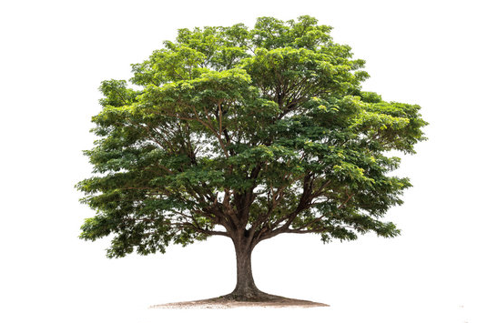

**Output:**

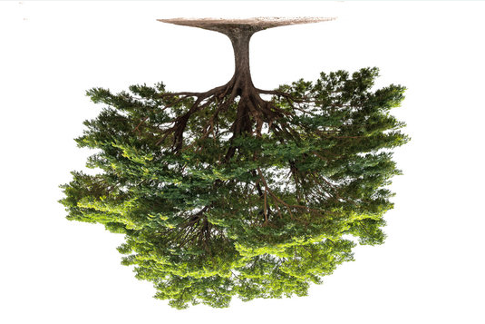

**Result:**

The input image has been rotated 180 degrees along the degree successfully.